FORMULAS

Size of formulas for MathType:
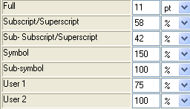

Size of formulas for MS Equation:
The size:
Normal 11pt
Big index 7pt
Fine index 5pt
Large character 15 pt
Small character 9 pt

Style of formulas:
